Under the guidance of Mr.Sachin

President, Pratibha Foundation, Vadodara, Gujarat

Kaushal Shah Assistant Professor,

Submitted to



Computer Engineering School of Technology

Pandit Deendayal Energy University July-2023

Under the guidance of Mr.Sachin

President, Pratibha Foundation, Vadodara, Gujarat

Kaushal Shah Assistant Professor,

Submitted to



Computer Engineering School of Technology

Pandit Deendayal Energy University July-2023

# Acknowledgement

* I, Dev Patel [22BCP185] would like to express our heartfelt gratitude to the Pratibha Foundation for their remarkable efforts in educating underprivileged children. The foundation's commitment to providing quality education to these kids is truly commendable.
* We are especially thankful for the foundation's unique approach, which involves interaction between the youth and the children. This innovative method not only educates the kids but also fosters a sense of men- torship and camaraderie.
* This acknowledgement would be incomplete without expressing our deep appreciation for Sachin Sir, the President of Pratibha Foundation. His visionary leadership and guidance have been instrumental in shaping the foundation's success. His unwavering dedication to the cause of education is an inspiration to all.
* The impact that the Pratibha Foundation has made in the lives of these children is immeasurable. By pro- viding them with access to education and nurturing their potential, the foundation is shaping a brighter fu- ture for these young minds.
* Once again, we extend our heartfelt thanks to the Pratibha Foundation and Sachin Sir for their unwavering commitment and the positive difference they are making in the lives of these children.

# Executive Summary

This report involves information about my experience during my internship at PRATIBHA FOUNDATION between 26th June to 9th July 2023. Basically PRATIBHA FOUNDATION is a unique platform provided by them to youth and kids as well as for Women Empowerment for the upliftment of society. As we are aware that in India there are still a lot of villages which are yet to be developed. Through their grassroots programs,

they are building a society where no child is deprived of education. This NGO focuses on providing quality education to children living in the urban slums of Vadodara and nearby regions. Using modern and child- friendly education techniques, this Gujarat-based NGO has been effectively rendering education facilities to thousands of children in and around Vadodara. Other than educating unprivileged children, this non-profit organisation is also contributing toward health care of downtrodden and backward masses living in villages of rural Gujarat. They mainly focuses on 3 areas academics, talent and moral.

* Mainly two projects are been worked on by Pratibha foundation

1. SKY-School for kids by youth
2. SWAA-Self welfare women association

This report is mainly focuses on pointing out the social issue in DENA VILLAGE (near Vadodara). It also includes the reason by which the problems arises, how can we help them and what necessary steps to be tak- en to solve the issue under the SKY project. It also mention the steps taken by government to solve this is- sue.

# Table of content

|  |  |  |
| --- | --- | --- |
| SR. No. | Contents | Page no. |
| 1 | Acknowledgement | 3 |
| 2 | Executive Summary | 4 |
| 3 | Table of Contents | 5 |
| 4 | List of Tables | 6 |
| 5 | List of Figures | 7 |
| 6 | List of Symbols, Abbreviation and Nomenclature | 8 |
| 7 | Chapter :- 1 , introduction | 9 |
| 8 | Chapter :- 2 , Aim & Objective | 10 |
| 9 | Chapter 3: Activities at NGO | 12 |
| 10 | Chapter 4: Major Societal Problems Encountered | 18 |
| 11 | Chapter 5: Methodology to Solve Societal Problems | 20 |
| 12 | Chapter 6: Major Learnings | 24 |
| 13 | Conclusions | 25 |
| 14 | Scope of Future work: Recommendations | 26 |
| 15 | Appendices | 27 |
| 16 | References | 29 |

# List of Tables

Table 1 Expense Per Student Per Year 11

Table 2 Budget - 2022 11

# List of Figure

[Figure 1 Painting of tree 12](https://d.docs.live.net/56e3b04ec9dfd97c/Desktop/project%20CSSR%20DEV.docx#_Toc141993541)

[Figure 2 Looks more Interested in drawing 12](https://d.docs.live.net/56e3b04ec9dfd97c/Desktop/project%20CSSR%20DEV.docx#_Toc141993542)

[Figure 3 Painting 12](https://d.docs.live.net/56e3b04ec9dfd97c/Desktop/project%20CSSR%20DEV.docx#_Toc141993543)

[Figure 4 Some of the Best painting 12](https://d.docs.live.net/56e3b04ec9dfd97c/Desktop/project%20CSSR%20DEV.docx#_Toc141993544)

[Figure 5 Small children play cricket 13](https://d.docs.live.net/56e3b04ec9dfd97c/Desktop/project%20CSSR%20DEV.docx#_Toc141993545)

[Figure 6 Some children wanted to study even though it was Sunday 14](https://d.docs.live.net/56e3b04ec9dfd97c/Desktop/project%20CSSR%20DEV.docx#_Toc141993546)

Figure 7 Some children are good at drawing 14

[Figure 8 Some Girls are good at kho-kho 14](https://d.docs.live.net/56e3b04ec9dfd97c/Desktop/project%20CSSR%20DEV.docx#_Toc141993548)

[Figure 9 Dodge Ball Game 15](https://d.docs.live.net/56e3b04ec9dfd97c/Desktop/project%20CSSR%20DEV.docx#_Toc141993549)

[Figure 10 Unfiltered Smiles 15](https://d.docs.live.net/56e3b04ec9dfd97c/Desktop/project%20CSSR%20DEV.docx#_Toc141993550)

[Figure 11 Birthday Celebration With Children 16](https://d.docs.live.net/56e3b04ec9dfd97c/Desktop/project%20CSSR%20DEV.docx#_Toc141993551)

[Figure 12 Dance activity with children 17](https://d.docs.live.net/56e3b04ec9dfd97c/Desktop/project%20CSSR%20DEV.docx#_Toc141993552)

Figure 13 [2015] Irregular Students - 60 % 18

[Figure 14 [2019] Irregular Students - 15 % 19](https://d.docs.live.net/56e3b04ec9dfd97c/Desktop/project%20CSSR%20DEV.docx#_Toc141993554)

[Figure 15 Old Cloths Collection 20](https://d.docs.live.net/56e3b04ec9dfd97c/Desktop/project%20CSSR%20DEV.docx#_Toc141993555)

[Figure 16 Making Bags from A4size paper 21](https://d.docs.live.net/56e3b04ec9dfd97c/Desktop/project%20CSSR%20DEV.docx#_Toc141993556)

[Figure 17 Making Paper bags from Newspapers 21](https://d.docs.live.net/56e3b04ec9dfd97c/Desktop/project%20CSSR%20DEV.docx#_Toc141993557)

[Figure 18 Paper Bag Handle are made with thred 22](https://d.docs.live.net/56e3b04ec9dfd97c/Desktop/project%20CSSR%20DEV.docx#_Toc141993558)

[Figure 19 Sachin sir (President of NGO) with Children 27](https://d.docs.live.net/56e3b04ec9dfd97c/Desktop/project%20CSSR%20DEV.docx#_Toc141993559)

**List of Symbols, Abbreviations and Nomenclature**

## Symbols

 :- SKY project

:- SWWA project

## Abbreviations

* **Etc** : Etcetera
* **NGO** : **N**on **G**overnment **O**rganization
* **SKY** : **S**chool for **K**ids by **Y**outh
* **PF** : **P**ratibha **F**oundation
* **SWWA** : **S**elf **W**elfare **W**omen **A**ssociation

## Nomenclature

* **Unprivileged** :- In social, economic, or political contexts, being unprivileged often means lacking access to resources, opportunities, or power that can lead to a better quality of life or increased social mobility. This lack of privilege can be based on various factors such as race, gender, socioeconomic status, disability, or other forms of discrimination or marginalisation.

# Chapter :- 1 Introduction

CSSI Internship was a selfless task given to students of Pandit Deendayal Energy University pursuing education in Engineering field. I completed the internship with Pratibha Foundation which is a global non profit organization that brings together professionals and community leaders to provide humanitarian services, promote goodwill, and foster peace and understanding. Pratibha Foundation is a NGO working for building a society where no child is deprived of their rights since 2011.Through their grassroot programs they have supported many people. They are working in more than 35 villages in India and impacting more than 35,000 lives through our various grassroots-level programs. . This NGO focuses on providing quality education to children living in the urban slums of Vadodara and nearby regions. Using modern and child-friendly education techniques, this Gujarat-based NGO has been effectively rendering education facilities to thousands of children in and around Vadodara. Other than educating unprivileged children, this non-profit organization is also contributing toward health care of downtrodden and backward masses living in villages of rural Gujarat. They mainly focuses on 3 areas academics, talent and moral.

Mainly two projects are been worked on by Prathibha foundation

1.SKY-School for kids by youth

2.SWAA-Self welfare women association

# Chapter :- 2 , Aim & Objective

*‘“A big change happens only when we take that first step even if its small, still it's worth it to achieve a big target”*

### Vision:

Pratibha Foundation began with a vision to uplift the down-trodden and backward masses where no children are deprived of their rights.

### Mission:

To put a halt to the dropout ratio of children from rural areas by endeavouring to develop an interest in stud- ies through recreation pursuit.

### Objective:

* Provide equal opportunity to the underprivileged children.
* Enhance their academic as well as their talent.
* Help them with their behavioural modification.
* Helping with overall development of their personality.

Our Activates under SWWA project :-

* + We Offer Them Vocational Training.
  + Paper Box Making.
  + Educating Women about Their Rights.

Table Expense Per Student Per Year

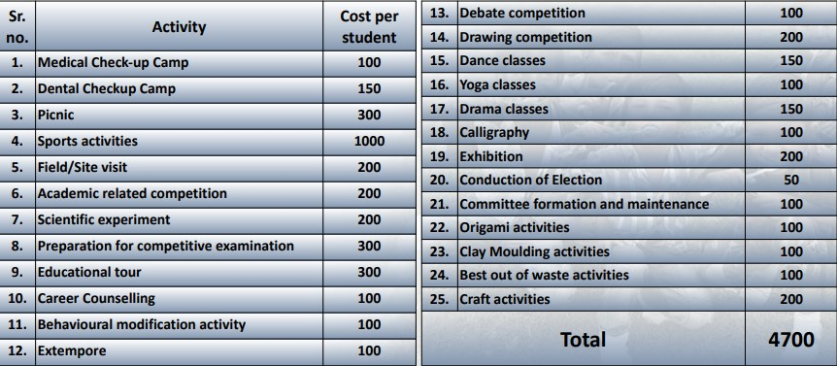

Table Budget - 2022

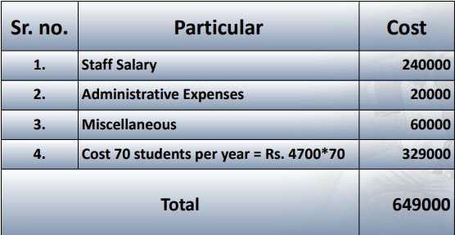

# Chapter :- 3 , Activity at NGO

* In NGO we conducted various activities with kids. We also noticed that kids enjoy painting, they are very creative in terms of artistic work. So we decided to do some artistic work with them and everyone partici- pated in it very actively.

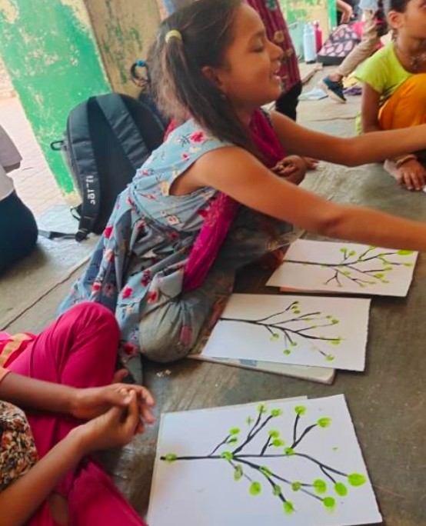

Figure 2 Painting of tree

Figure 1 Looks more Interested in drawing

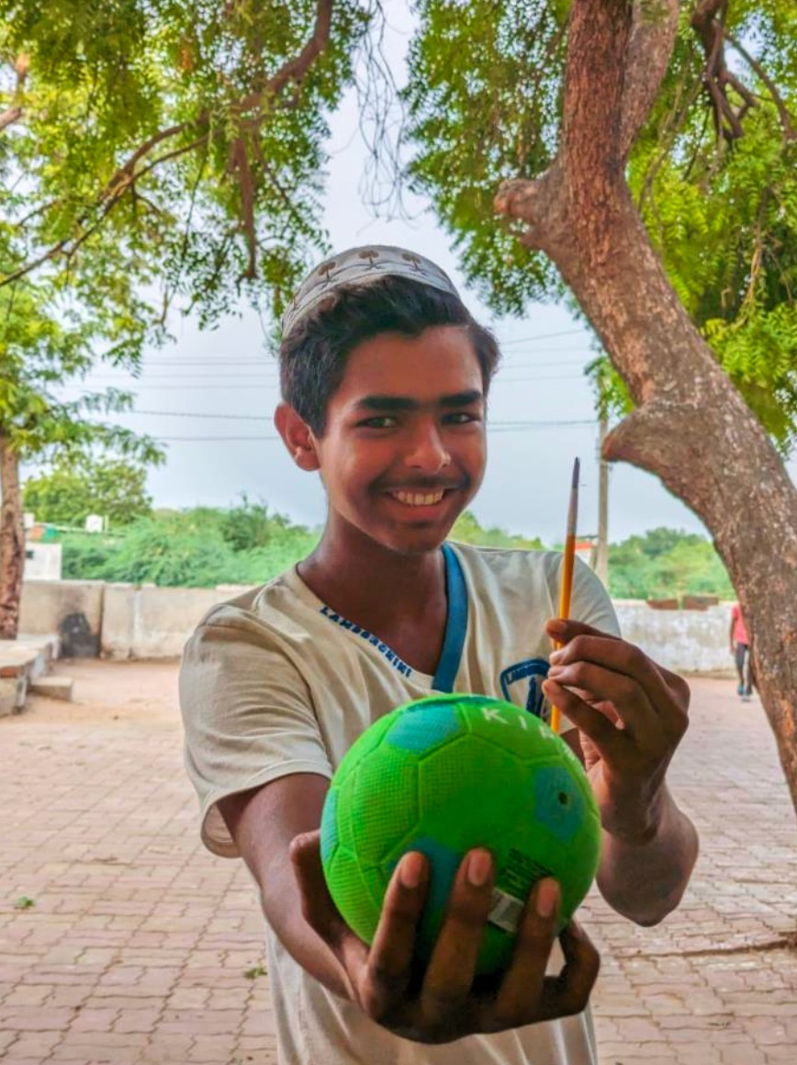

Figure 3 Painting

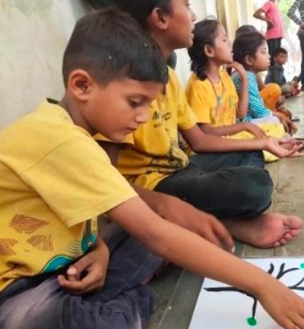

Figure 4 Some of the Best painting

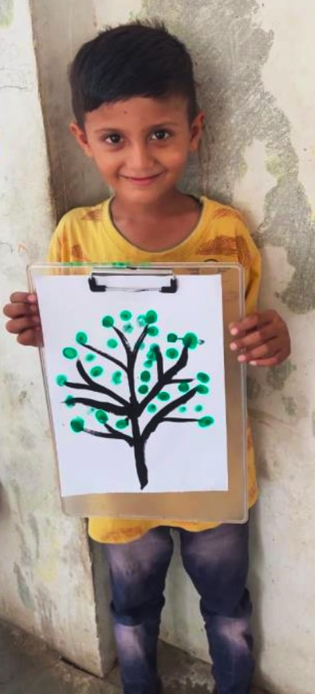

* Some children are very good at cricket and catch the ball game, so we decided to play with them at Dena.

Figure 5 Small children play cricket

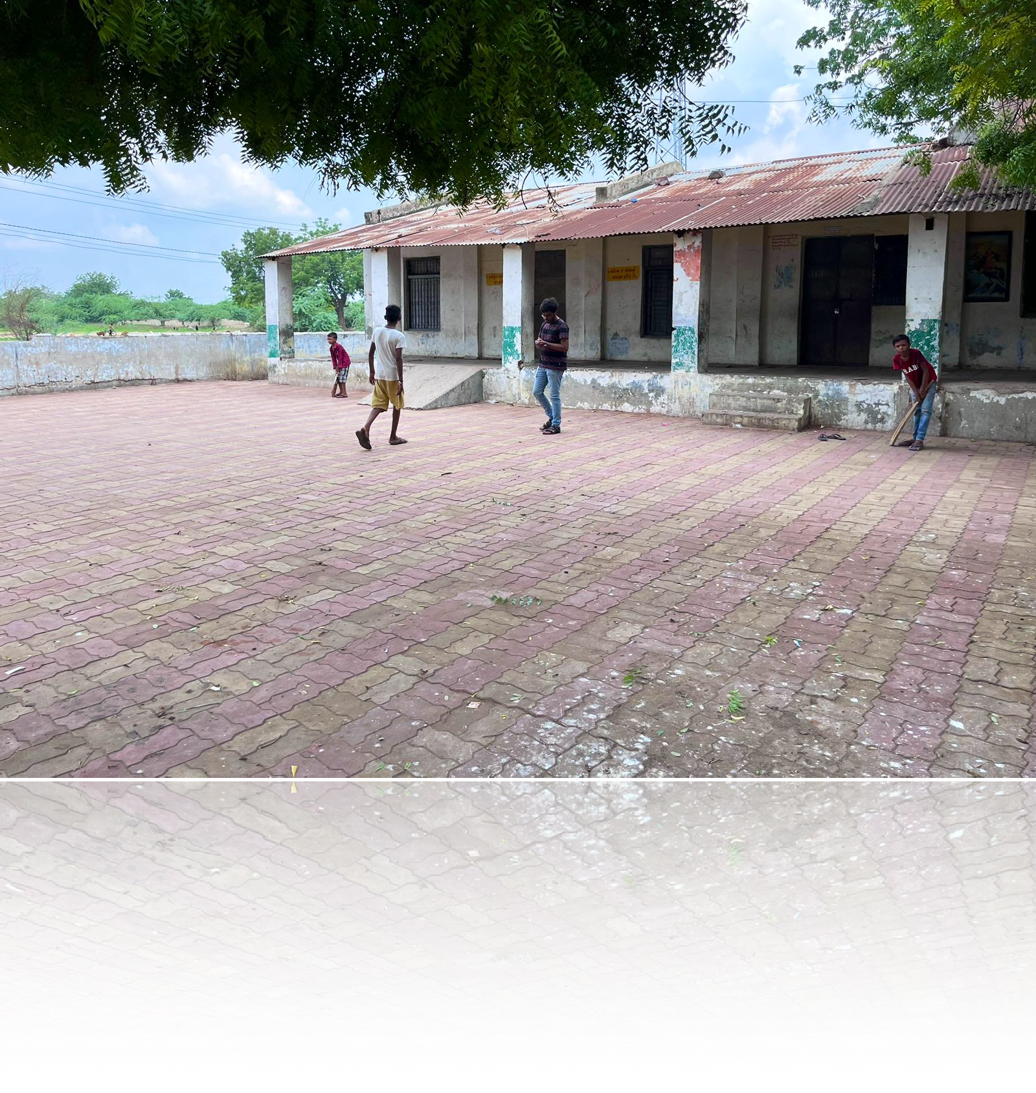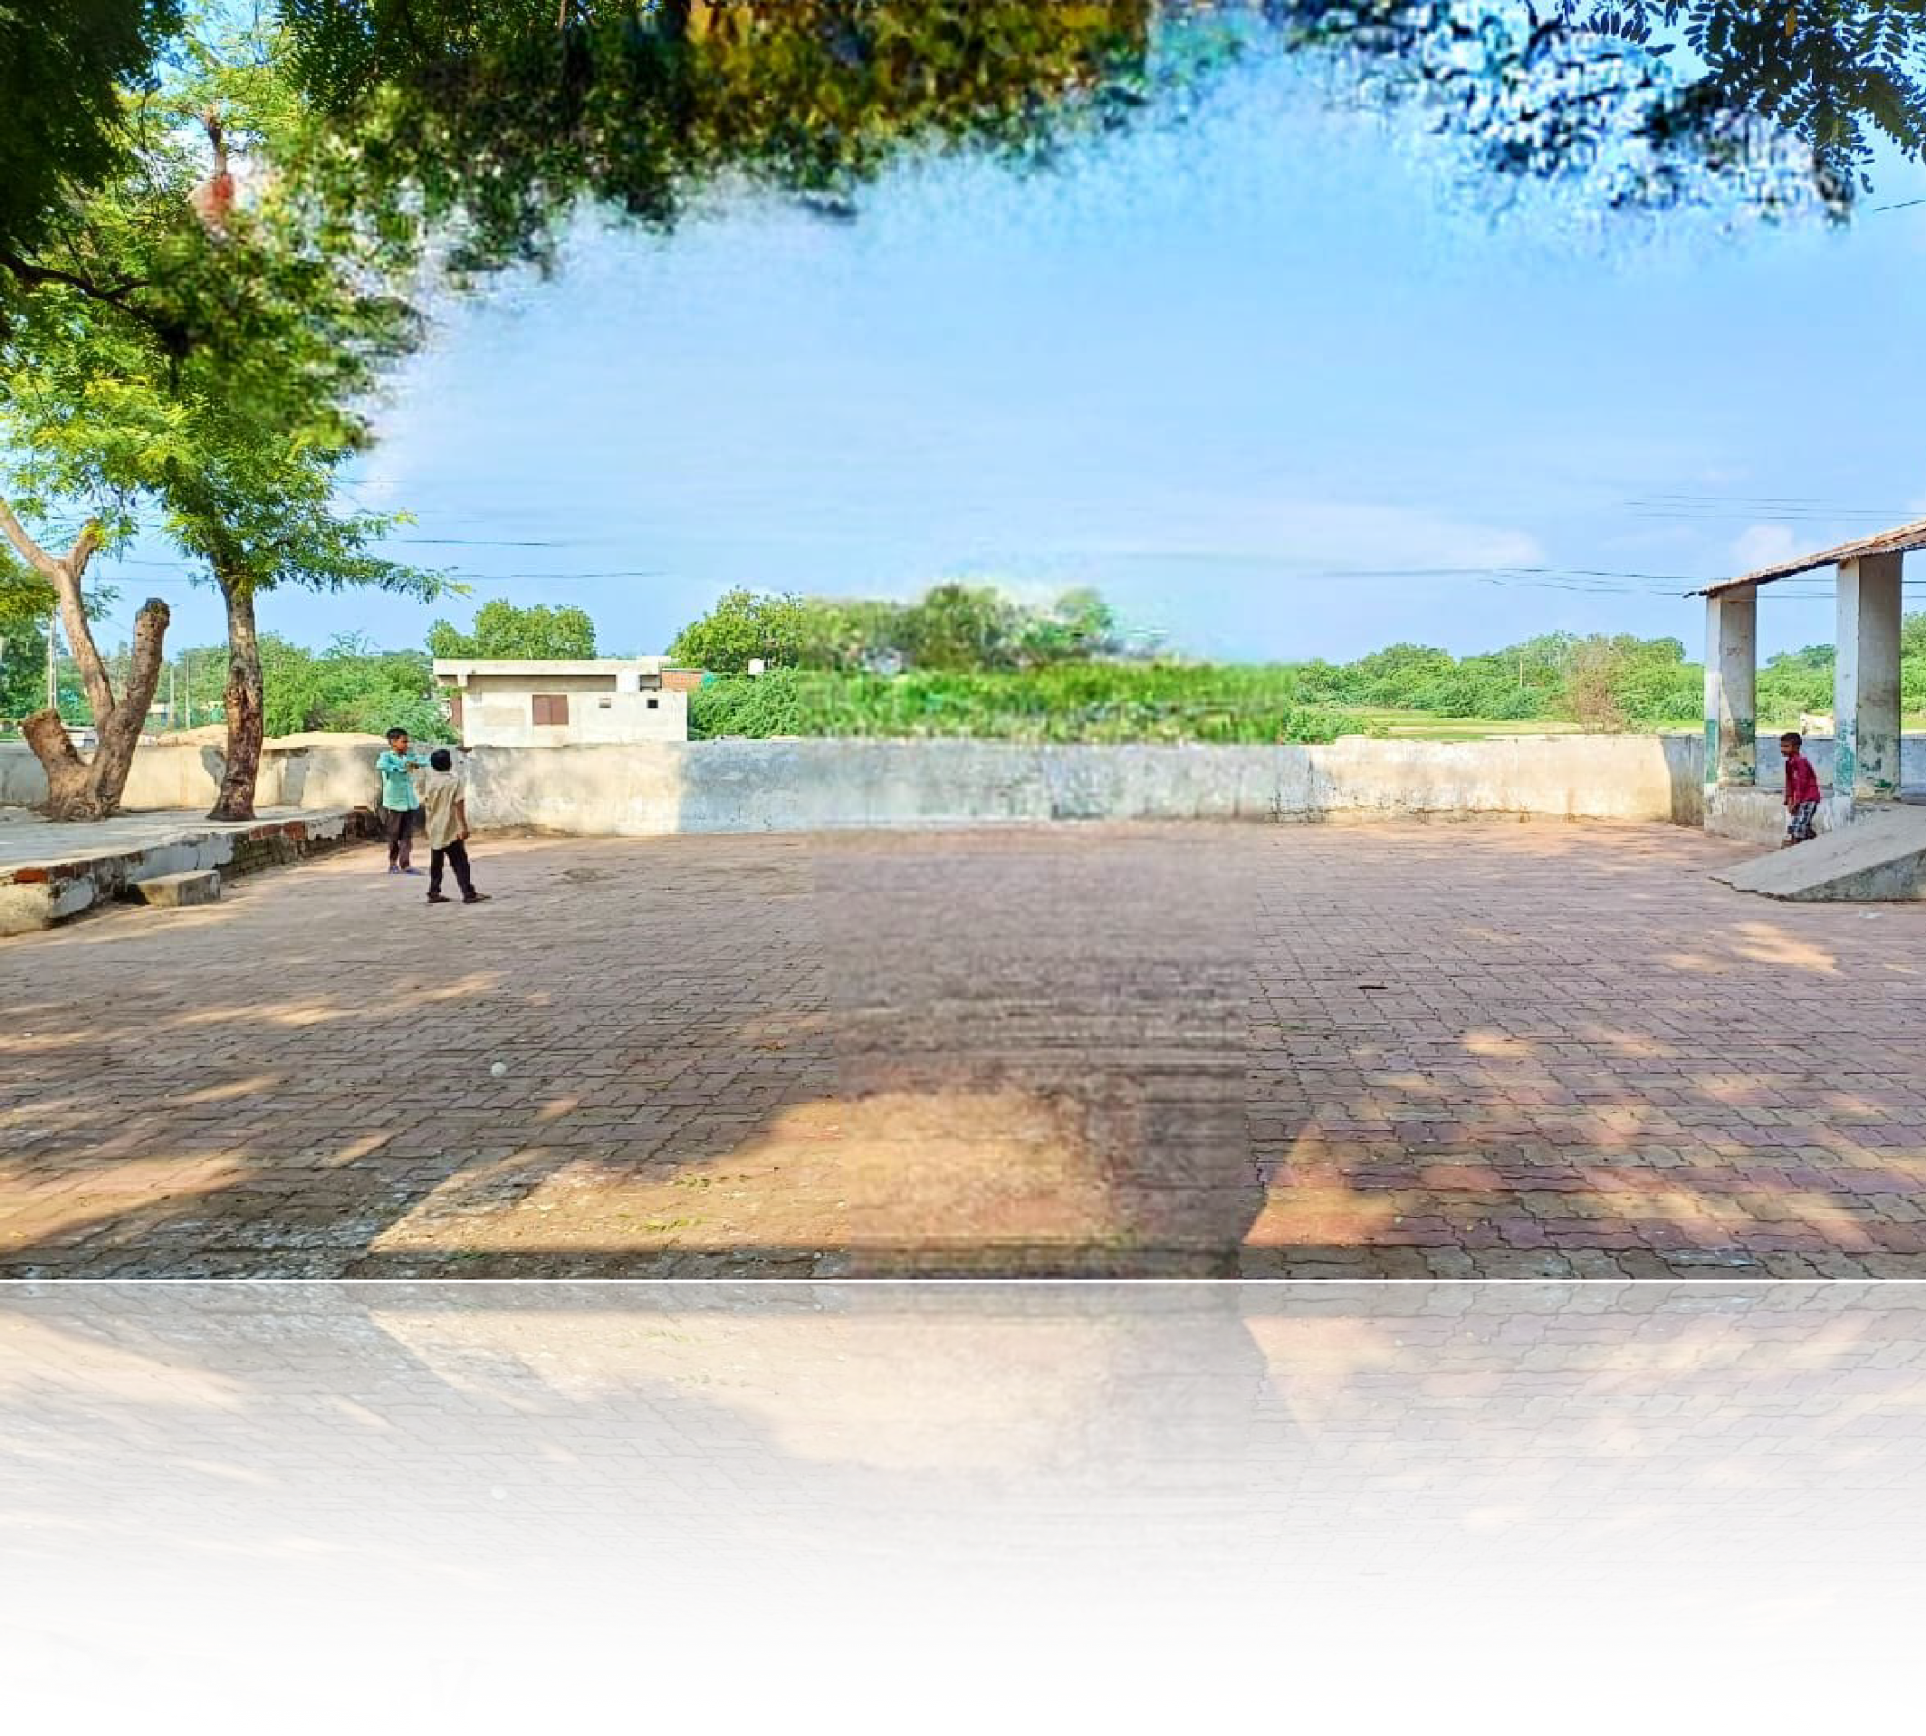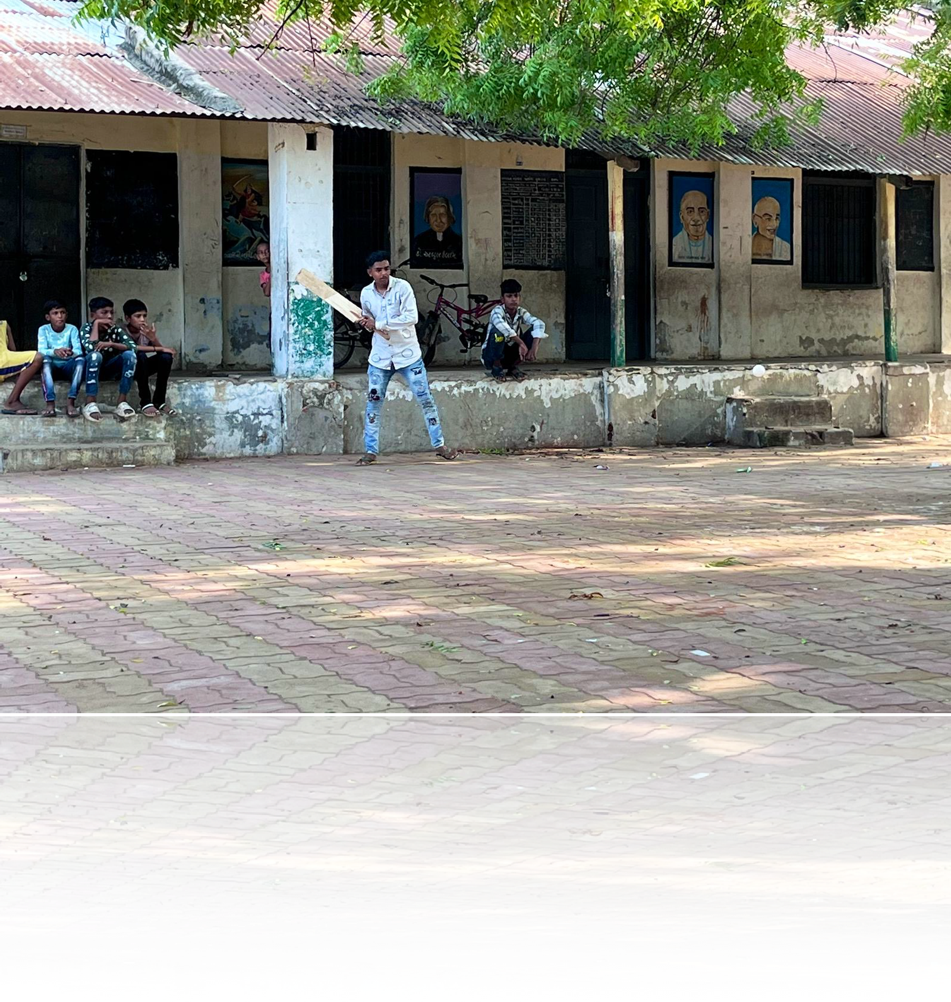

Small children play with plastic balls

While other children play with tennis balls

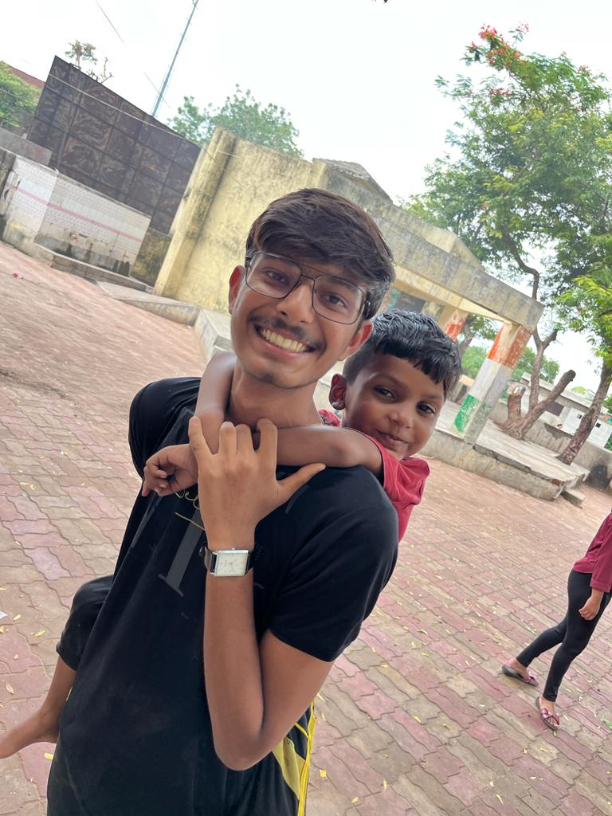

Figure 7 Some children wanted to study even though it was Sunday

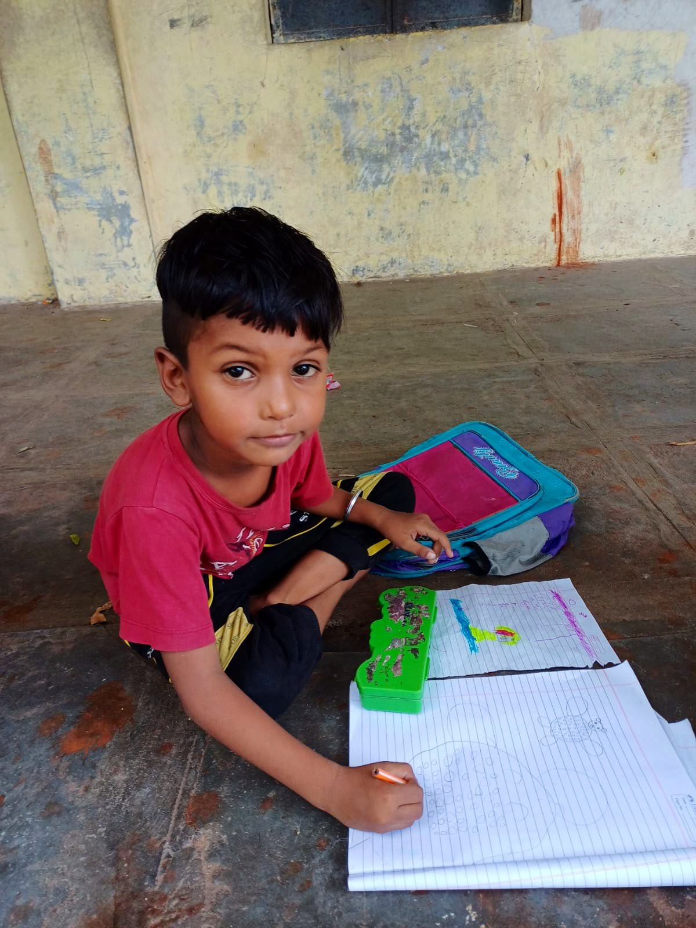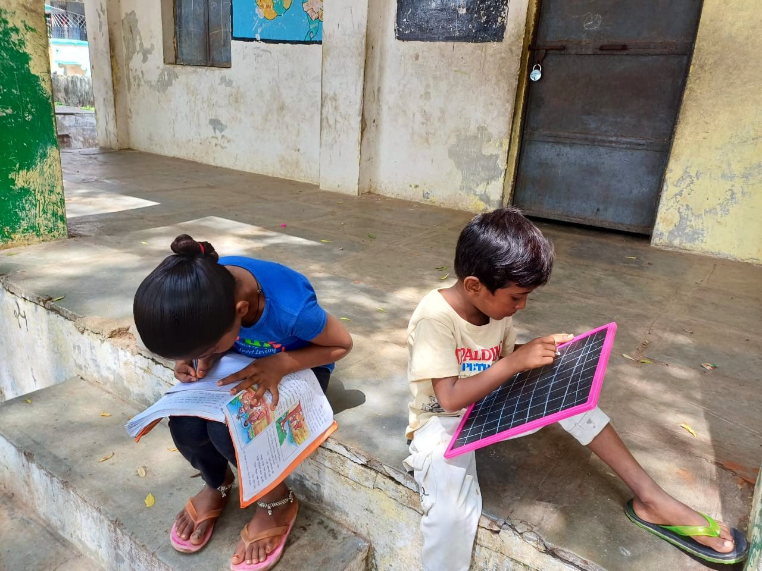

Figure 6 Some children are good at drawing

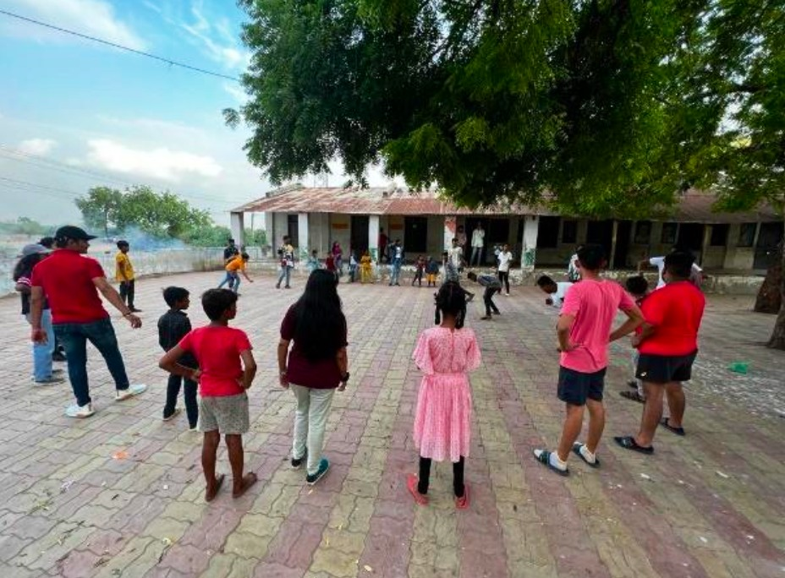

Figure 9 Some Girls are good at kho-kho

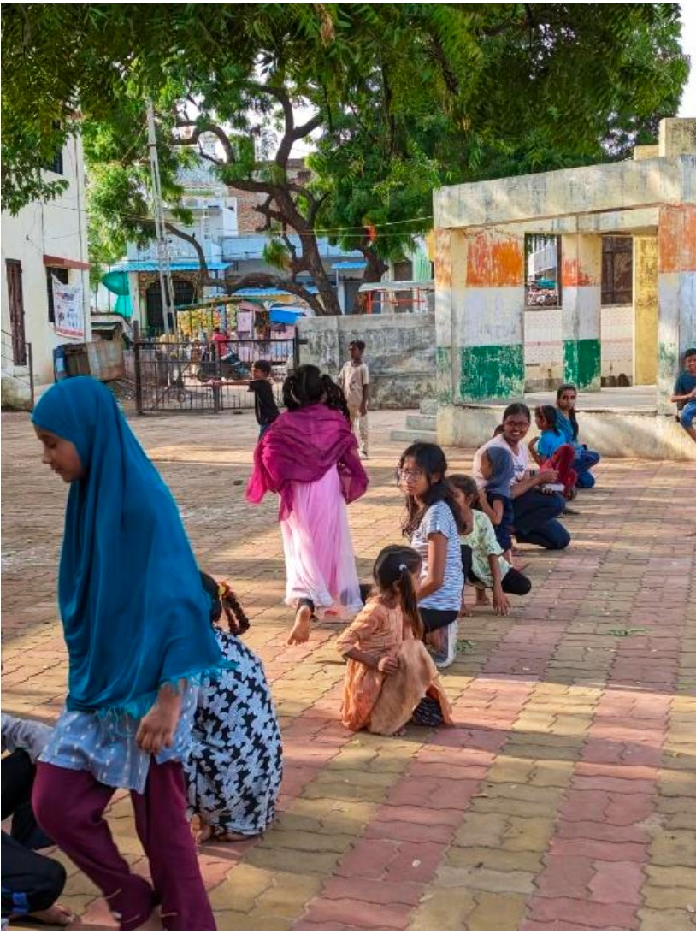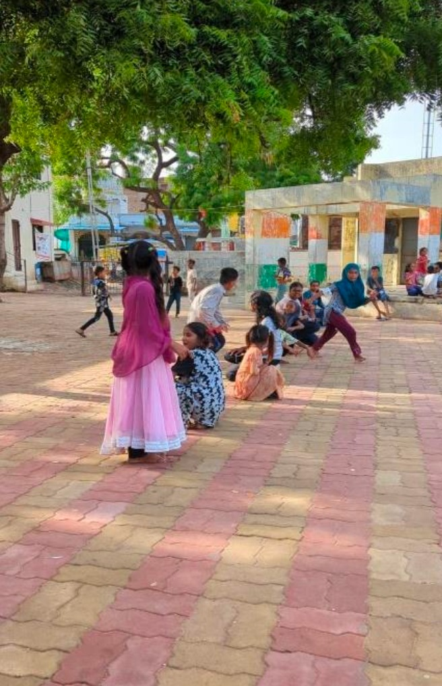

Figure 8 Dodge Ball Game

* BIRTHDAY CELEBRATION:

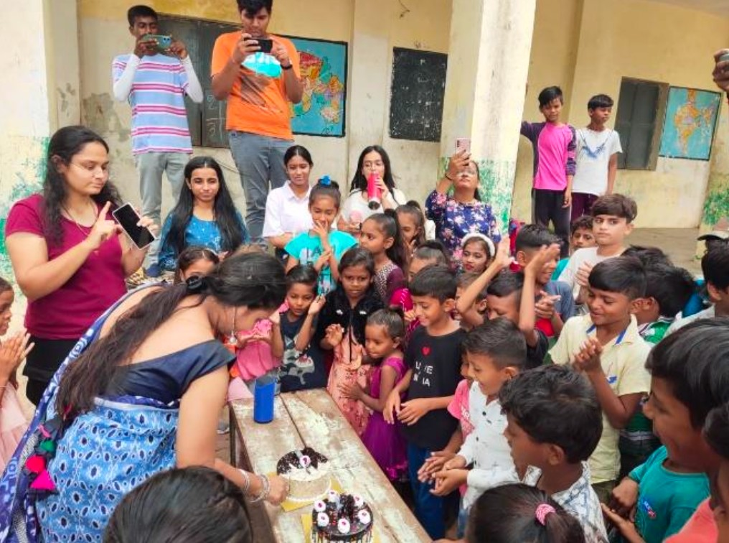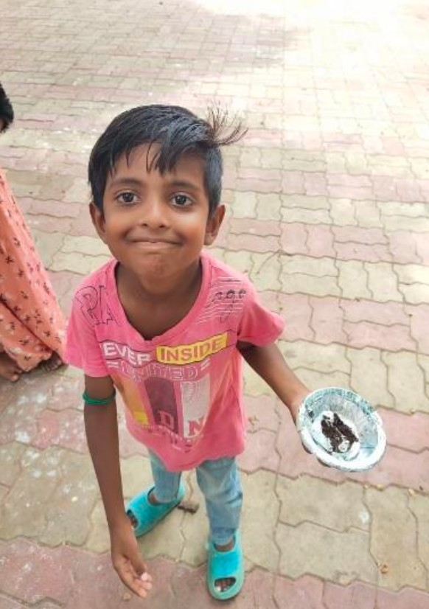

Figure 11 Unfiltered Smiles

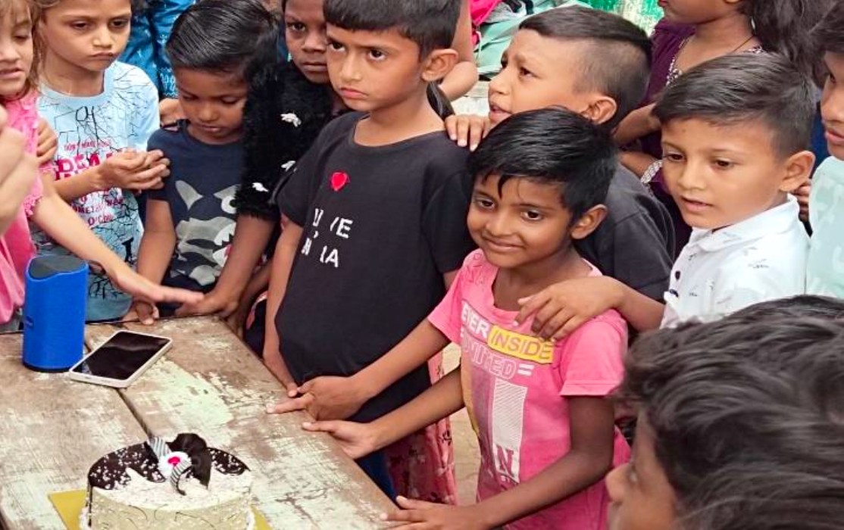

One of our NGO’s donor celebrated her Birthday with the children of Dena Village.

Figure 10 Birthday Celebration With Children

* Although Dena Village is primarily a Muslim community, I was surprised when, during our dance activi-

Figure 12 Dance activity with children

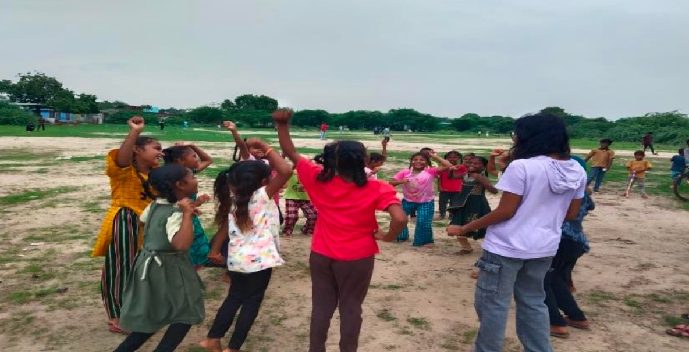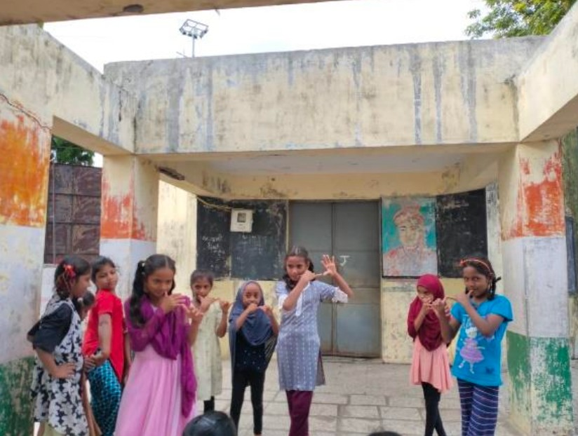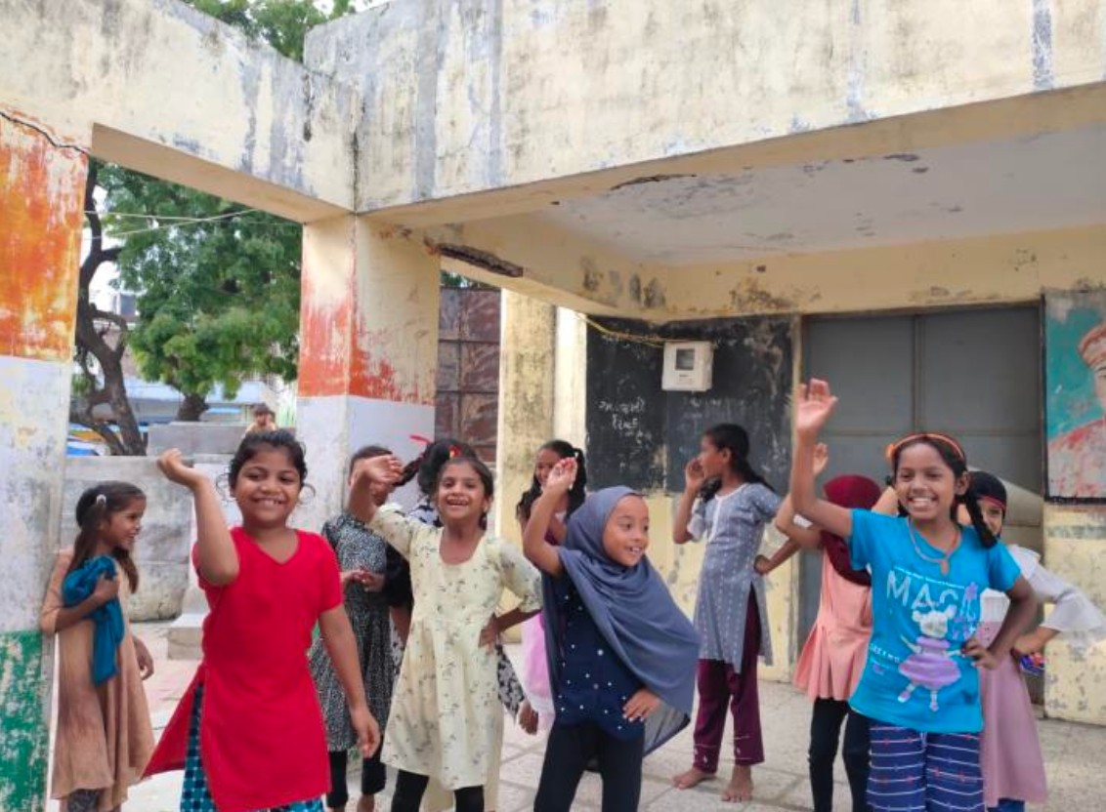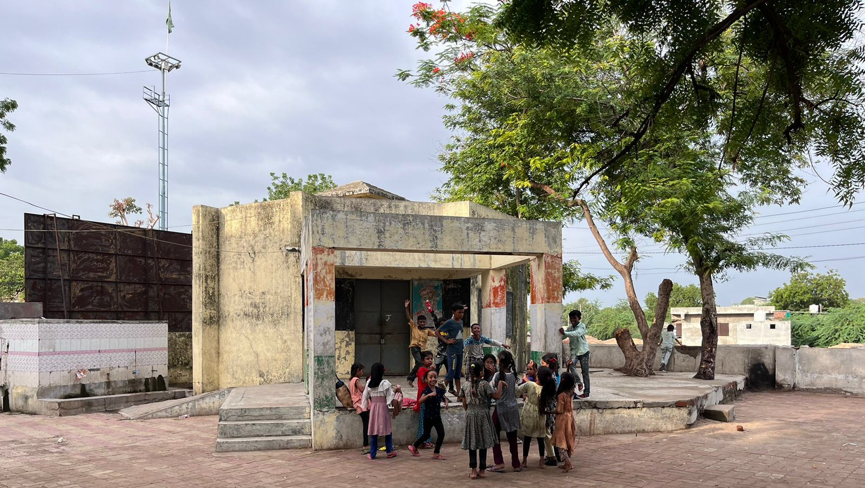

ties, some children requested to play the song "Jai Shree Ram."

# Chapter :- 4 , Major Societal Problems Encountered

* Outdated and uninteresting education system
* Very poor academic performance
* Poor ratio of reading and writing skills
* Weak grammar and pronunciation skills
* Difficulty in solving simple one-digit problems for children aged 6-12
* Lacking basic knowledge of division
* Irregular attendance
* Behavioural problems
* Lack of parental interest
* High ratio of dropout students

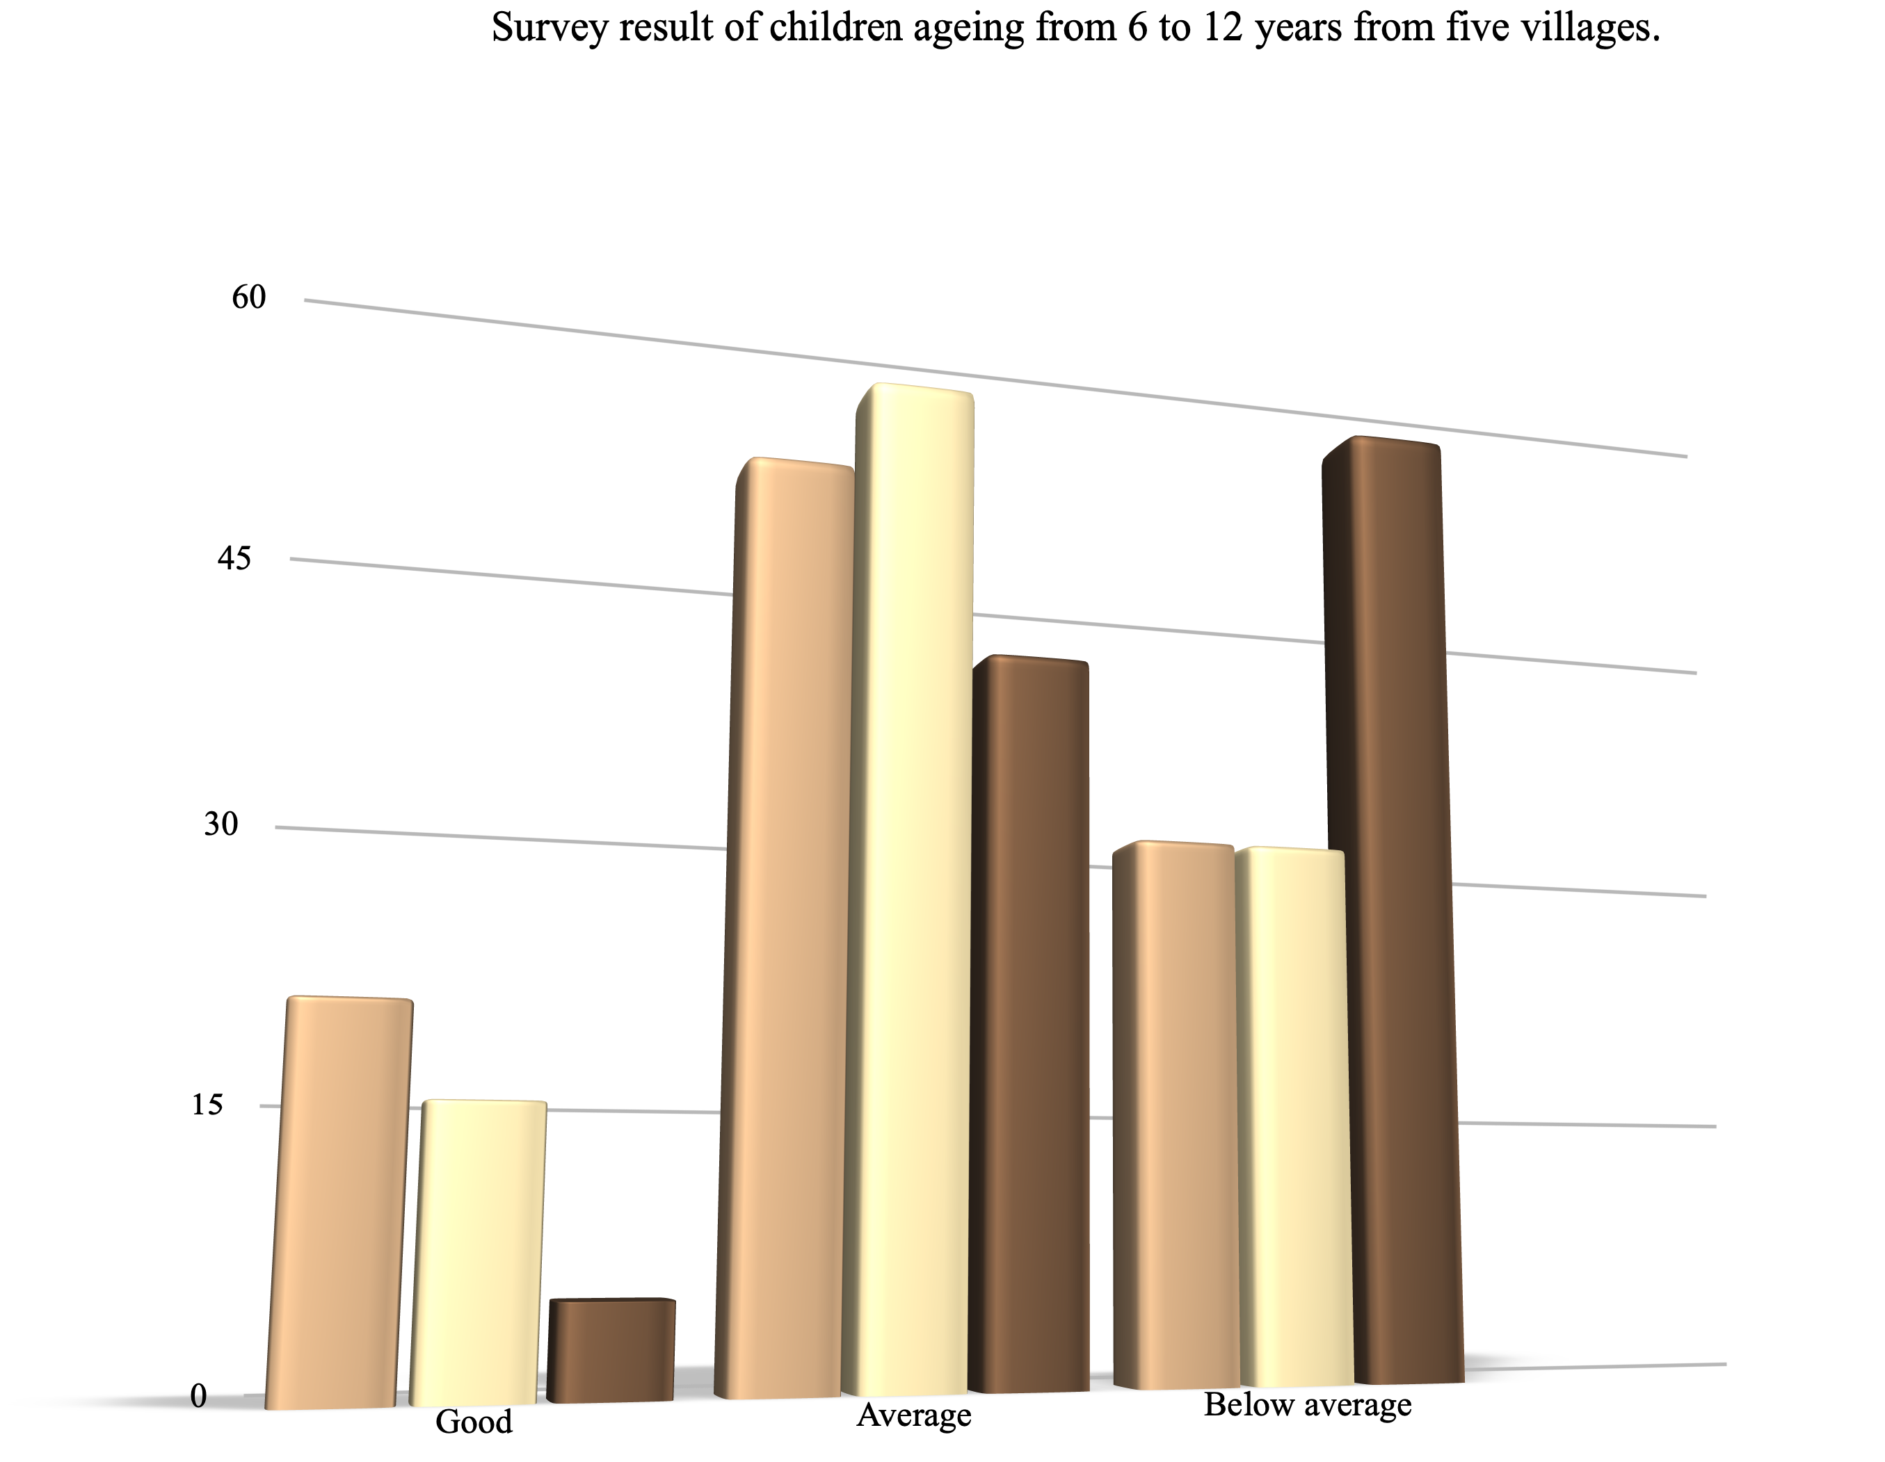

Writing

Reading

Calculation

Figure 13 [2015] Irregular Students - 60 %

Figure 14 [2019] Irregular Students - 15 %

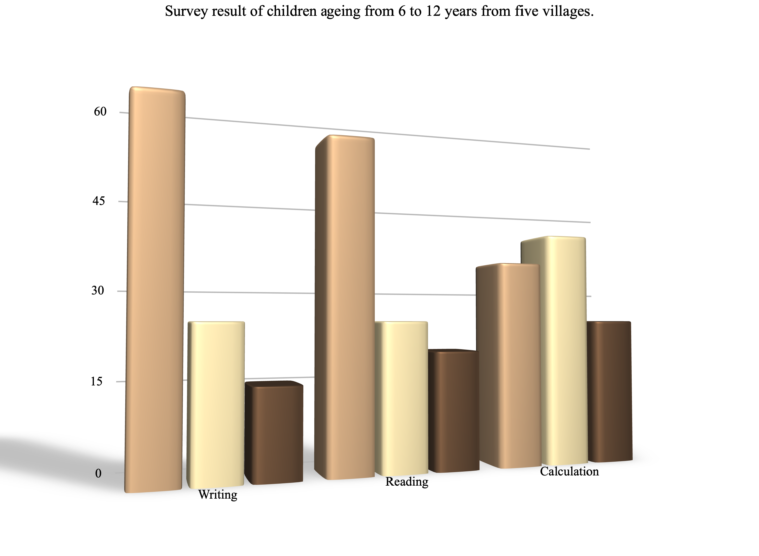

Good Average Below average

* Dealing and spending a few days with those village kids the major problem which we encountered was

that watching the children eating ‘Meethi Supari’, ‘Vimal’ and many other addictive things which are

injurious to health and seeing such small kids doing so and also influencing the children younger than

them to do so was really heartbreaking. They were also proud of doing such things.When we told them

to stop these things and explained them how these things can harm them and even asked them the

reason of eating such things then they just replied “It’s our pleasure and we will continue eating these

things”.

* Well according to me this is really a problem should be taken in concern.
* Another problem seen was that the children had lack of knowledge of English which in todays world

can take them towards higher risk with rising competitions.

# Chapter :- 5 , Methodology to Solve Societal Problems

1. ​

Figure 15 Old Cloths Collection

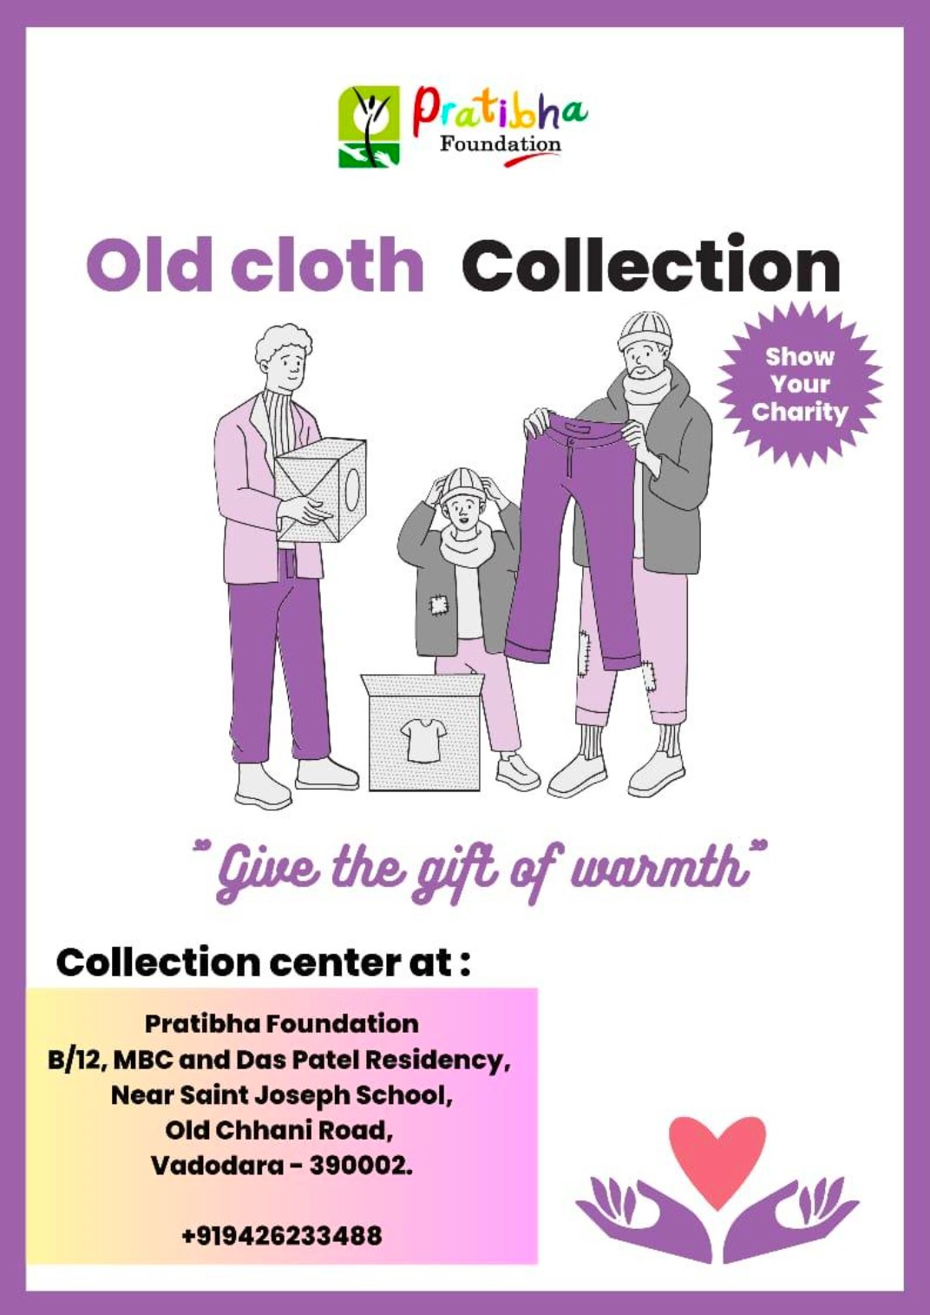

1. Pratibha Foundation is actively collecting old clothes in good condition to address the clothing needs of children who require assistance. Recognising the importance of providing adequate clothing to children in need, the foundation aims to ensure that these children have access to clean and suitable clothing. By gathering donated clothes from the community, Pratibha Foundation strives to make a positive impact on the lives of these children. This initiative not only meets their basic clothing requirements but also helps foster a sense of dignity and self-esteem. The foundation plays a crucial role in bridging the gap and pro- viding essential clothing to those who might otherwise go without. Through the support and generosity

of individuals, Pratibha Foundation endeavours to create a positive change in the lives of these children and empower them with the resources they need for a better future.

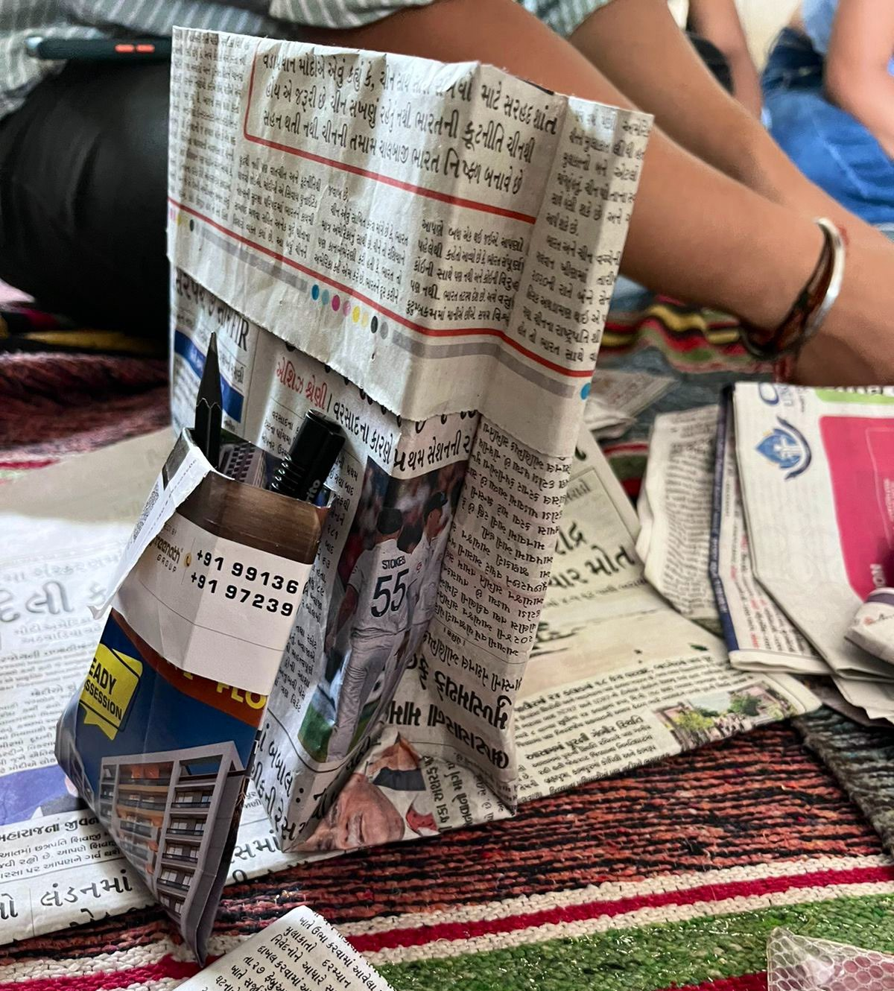

Figure Making Bags from A4size paper

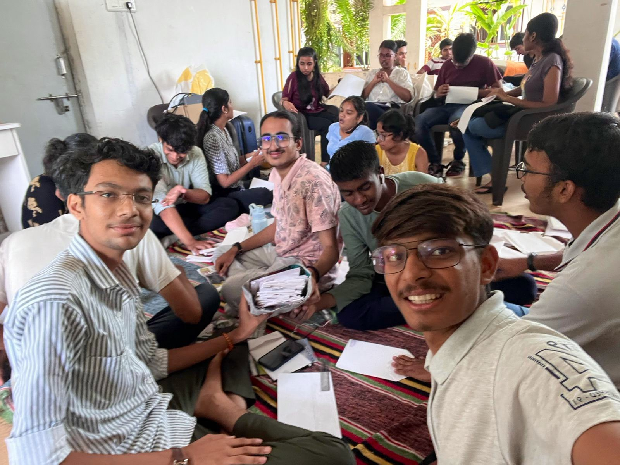

1. Paper Bags Making :-

Figure 16 Making Paper bags from Newspapers

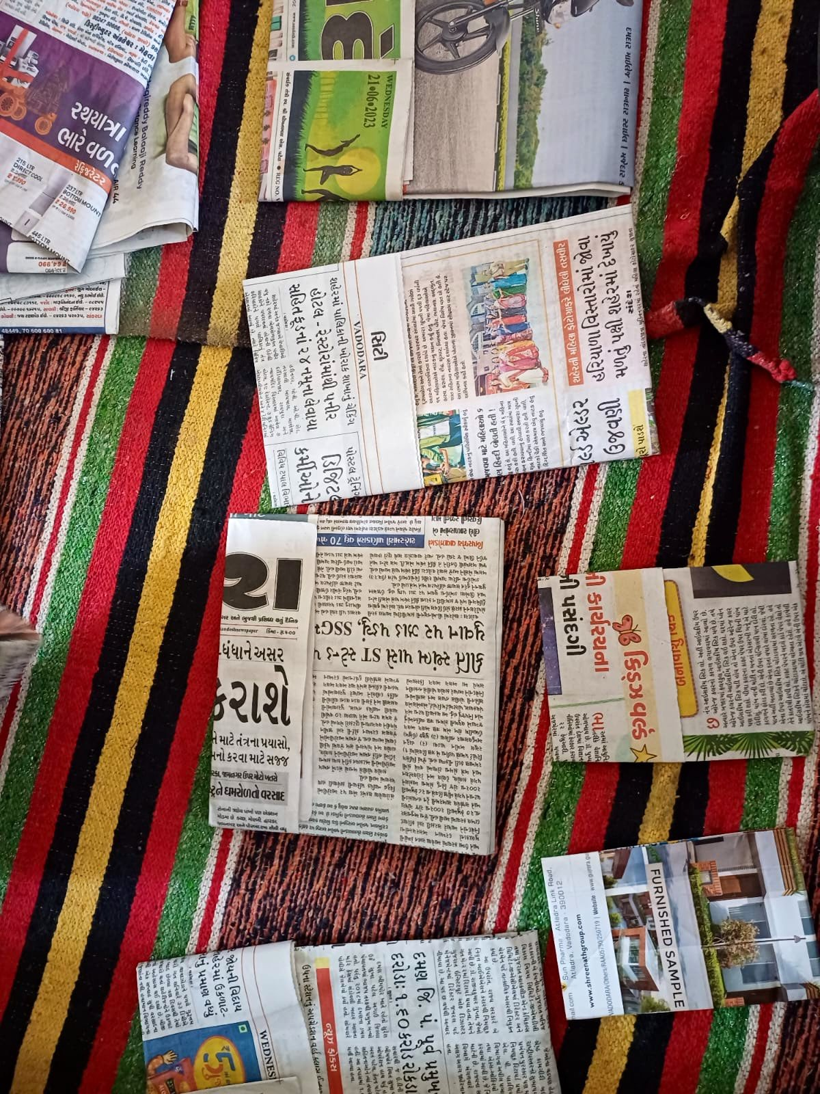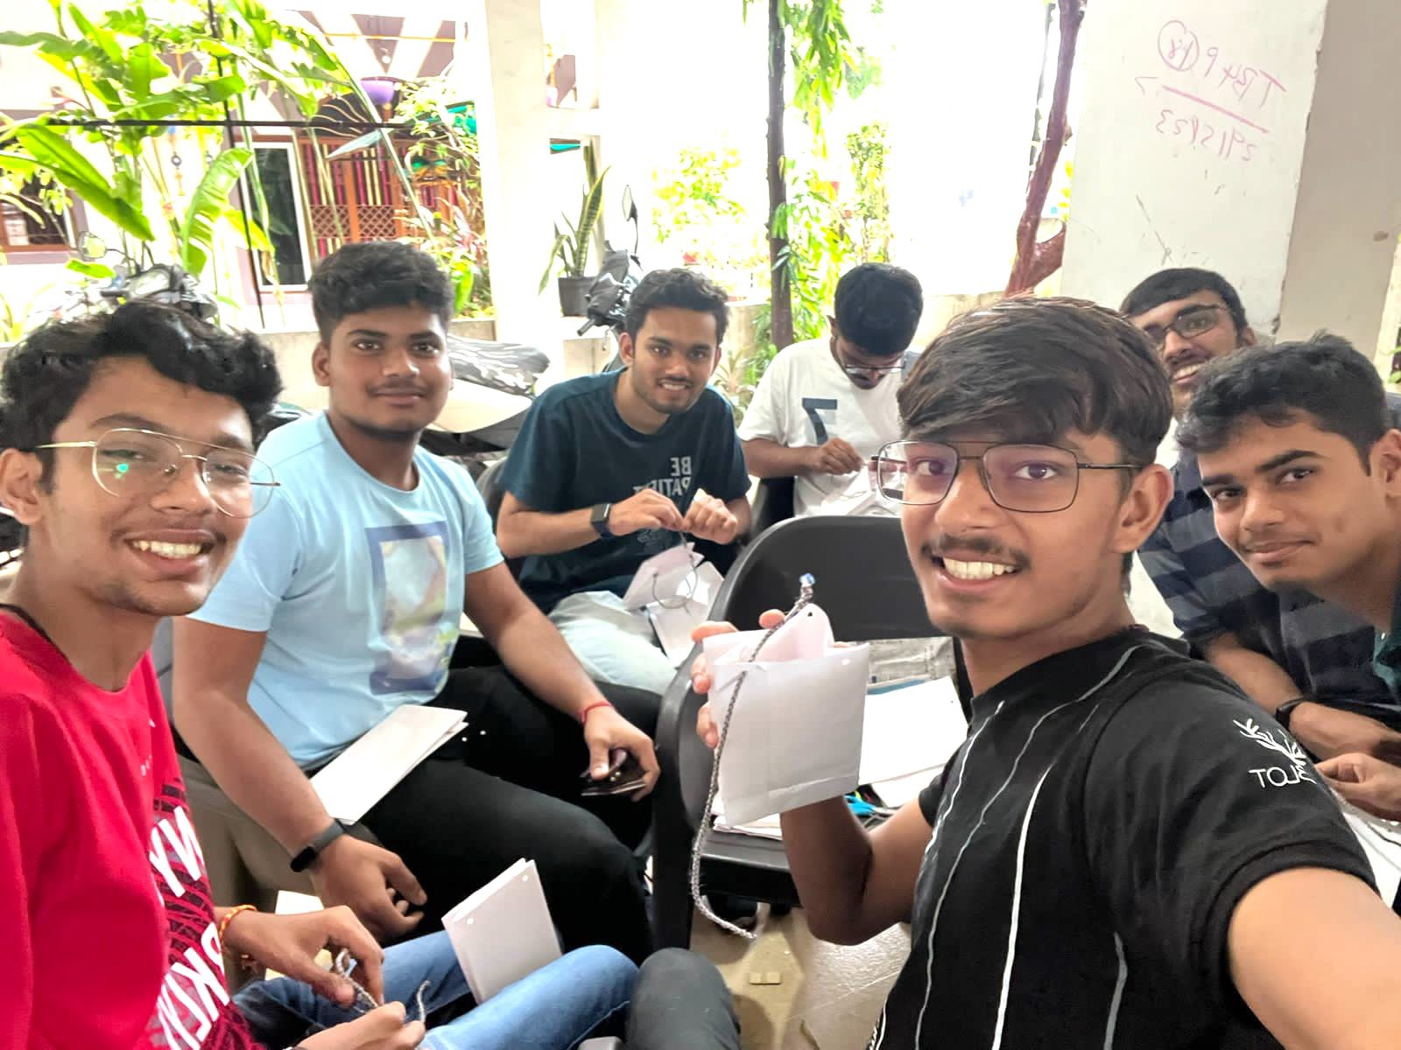

Figure 17 Paper Bag Handle are made with thred

* 1. During my internship at Pratibha Foundation, one of the projects I actively participated in was the creation of paper bags. With an aim to promote sustainability and reduce plastic waste, we dedicated ourselves to crafting eco-friendly alternatives.
  2. We gathered recycled paper materials and carefully designed and constructed the bags using various tech-

niques. Our focus was on creating sturdy, functional, and aesthetically pleasing bags that could be used for shopping, carrying books, or any everyday need. By engaging in this activity, we not only contributed to environmental conservation but also raised awareness among the community about the harmful effects of plastic.

* 1. It was a fulfilling experience as we witnessed the positive impact of our efforts in reducing plastic usage

and embracing sustainable practices. The paper bags we produced were distributed to local businesses, schools, and community events, emphasising the importance of eco-conscious choices. Overall, the in- ternship at Pratibha Foundation provided me with invaluable hands-on experience in promoting environ- mental sustainability through creative and practical means.

1. For students lake of attendance and lake of interest :-
   1. Engaging children in interactive games that combine study and play has proven to be an effective method of solving major problems related to learning, particularly in subjects like mathematics. Through creative gameplay, we can make learning enjoyable and help children develop essential skills. For example, using a cricket-themed game, we introduced the concept of addition to children by assigning runs to specific numbers. By asking questions like "If you hit a four and then hit another four, how many runs will you have?", we encouraged children to think critically and solve simple addition problems.
   2. These interactive games not only made learning mathematics fun but also improved their problem-solving

abilities and mental agility. Through various creative approaches, such as using visual aids, manipulatives, or incorporating storytelling, we further enhanced their engagement and understanding.

* 1. By incorporating easy games with study, we tackled major challenges like math anxiety, lack of interest,

and difficulty in grasping concepts. The playful environment created a positive association with learning, boosting their confidence and motivation to participate actively.

* 1. Moreover, these interactive games facilitated peer interaction, teamwork, and healthy competition among

the children. They learned from each other, shared strategies, and developed communication skills while enjoying the process.

* 1. Additionally, the integration of technology, such as educational apps or interactive online platforms, fur-

ther enhanced the gameplay experience. These tools provided instant feedback, personalised learning paths, and immersive visuals, making learning more captivating and effective.

* 1. Overall, by infusing simple math problems within creative gameplay, we successfully addressed major

challenges in children's learning. They not only improved their mathematical skills but also developed a positive attitude towards studying, fostering a lifelong love for learning and problem-solving

# Chapter :- 6 , Major Learnings

During my internship in this NGO, I learned so many things and understood **importance of small things in life** which earlier didn’t matter to me. We had encounters where children coming to our centre was re- ducing and that included mostly of girls.

I observed one important thing is that at the Dena village there were one boy who has to eat a **Gutka (Tobacco)** we had seen it by our own eyes. We stopped him and gave him the knowledge about the thing that What will happen in future if we have to eat tobacco!!

When we distribute the clothes at that time, I observed that there were some people who has not have a capacity to buy a cloth so we gave them the clothes which is in good condition.

* ‘Team Work’- NGOs are often small, close-knit organizations. This means that we had the opportunity

to learn how to work effectively as part of a team. We learnt how to communicate and collaborate with

others, and how to resolve conflicts.

* ‘Tolerance’-Patience and being calm,Control of your anger issues these are the major learnings

achieved by me from this internship.Really dealing with kids that too a good amount of kids is one of

the difficult task to do but after this internship I can say that yes I can do this job not to the perpection

mark but yes upto a good mark.

* ‘Empathy’- We got the skill to understand children’s feelings and thought by face reading.Sometimes

just by looking at their faces we were able to understand that they actually got the concept or not.This

skill would be really useful in future when we need to deal with presentation and skills.

* ‘Selfless Service’- We volunteered work without any personal gain.There were many who were serving

the NGO for years with solemn dedication of time and energy. This gave us a value that we must spare

some time for service and for society.That would give us immense contentment.

* ‘Smile in every situation’- Sweet smiles , sparkling white teeths of these childrenmade me realize one

thing that in any situation of my life,I would keep a smile on my face, which would give me a huge

strength to tickle my life problems.

# Conclusion

* On the whole, this internship was a useful experience. I have gained new knowledge, skills and met many new people. I learned the different facets of working within a NGO.I have been able to meet and network with so many people that I am sure will be able to help me with opportunities in the future.
* I think there is no use of law till you don’t know only that what law is, the children are ambitious what they want to do but how to achieve, they want to go school but for only fun part, I want to conclude that education is so much important the children are getting education but education system is so worst in our country they are only doing things because they are force to do not by themselves.
* For this amazing experience, I would like to thank the Faculty of computer science department Kaushal Shah, which includes such internship programmes in order to cultivate practical knowledge experience of real world in the students.

# Scope of Future work: Recommendations

The scope of future work for Pratibha Foundation as an NGO is vast, and there are several recommendations to consider:

* **Ground Reality Assessment:** Conduct an in-depth assessment of the ground reality faced by under- privileged children in the target communities. This will help identify specific needs, challenges, and areas where the foundation can have the most significant impact.
* **Targeted Assistance**: Focus on providing targeted assistance to children in need, considering factors such as socio-economic background, access to education, healthcare, nutrition, and overall well-being. This will ensure that resources and interventions are directed towards those who require them the most.
* **Eco-friendly Initiatives:** Expand the foundation's efforts towards promoting a sustainable environ- ment by incorporating eco-friendly practices. One specific initiative could be the production of eco- friendly bags, using recycled materials or biodegradable alternatives. This not only addresses the issue of plastic waste but also creates employment opportunities for local communities.
* **Comprehensive Social Work**: Broaden the scope of social work activities to address various social issues faced by underprivileged communities. This can include initiatives related to healthcare, sanita- tion, women empowerment, skill development, and community development projects. A comprehen- sive approach will contribute to holistic community development.
* **Collaboration and Partnerships**: Strengthen collaborations and partnerships with other NGOs, gov- ernment agencies, corporations, and community-based organisations. By joining forces, pooling re- sources, and sharing expertise, the foundation can enhance its impact and reach a larger audience. Empowering Local Communities: Implement initiatives that empower local communities to take own- ership of their development. This can involve fostering community leadership, providing opportunities for community participation, and promoting sustainable self-help initiatives.
* **Education and Skill Development**: Strengthen educational programs and incorporate skill develop- ment components to enhance the employability of children and youth. This can include vocational training, career guidance, scholarships, and mentorship programs to equip them with practical skills for a better future.
* By implementing these recommendations, Pratibha Foundation can expand its scope of work, address crit-

ical social issues, and create a lasting impact on the lives of underprivileged children and their communi- ties.

**Appendices**

Figure 19 Sachin sir (President of NGO) with Children

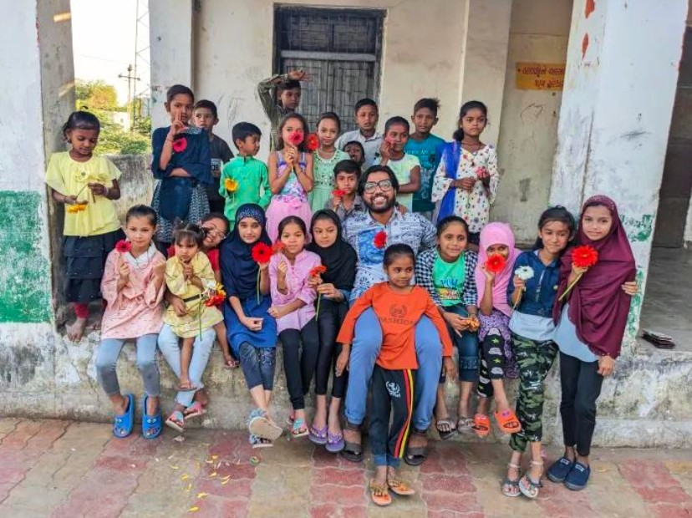

“I met her for the very first time during my awareness activity as an NSS volunteer. She was a 12-year-old,

bright, happy girl who wanted to be a teacher. I remember she participated in the competition my team

organized at the government school in their community. She gave a speech about the fierce warrior Rani

Lakshmibai and won first prize in the competition.”

When I visited the school again the next year, I was shocked to learn that she discontinued her studies. Her

family made her work as a household help so that she could help with the family expenses, and after that,

her family arranged for her to marry at the mere age of 16 years. That’s when I decided to start a movement

to protect children like Pratibha.

Pratibha Foundation is not only an organization but a mission to protect the rights of every child”.

This is the story of the birth of the idea of starting the ‘PRATIBHA FOUNDATION’ in the mind of our Cofounder and the President of our NGO Mr.Sachin Solanki

Pratibha means Talent!

Pratibha Foundation was established in 2011 by group of 4 friends. At the beginning it was PRATIBHA

GROUPS but in 2014 it officially became PRATIBHA FOUNDATION. They are a Gujarat-based nonprofit

working towards building an equal, inclusive, and self-dependent society that safeguards the rights of children. They are working in more than 35 villages in India and impacting more than 35,000 lives through our various grassroots-level programs.

**❖ Currently running two important projects of the NGO:**

o SKY-School for kids by youth

Through the SKY program, we focus on government primary schools in rural and urban-slum areas. Our

goal is to:

* Decline the drop-out ratio through learning-based fun activities and infrastructural development in

government schools.

* Provide remedial sessions and enhancement classes for students.
* Train teachers about children’s rights,new education techniques and best practices at schools.

o SWAA-Self welfare women association

We build self-help groups of mothers and build their capacity through skill development training and

awareness sessions.

* Our integrated model connects these associations with Anganwadi, ASHA, and ANM workers and

brings all of these representatives on a common stage to launch joint efforts against children’s issues

like health, nutrition, and pre and postnatal care.

* Working Structure of SWWA

So far Pratibha Foundation has supported 30,000+ children, 550+ mothers by working and conducting their

programs in around 35+ villages with the support of around 800+ volunteers.

The backbone of PF is a group of empowering teachers and medical experts interested in serving the

unprivileged communities. Through a collaborative approach, Pratibha  Foundation has been working to uplift

the education standard of children living in the slums. Giving them a bright future is the aim of the NGO.

**❖ Below are some Goals of our Pratibha foundation**

➢ VISION

We want to build a world where no children are deprived of their rights.

➢ MISSION

Create a parallel support system for government school children and teachers to make quality education

more accessible.

Build the capacity of mothers through building self-help groups and skill-based training programs.

Mobilize and create self-dependent communities through outreach, awareness, and training

**References**

(Website of Pratibha Foundation) : <https://pratibhango.org/>

(Social Media Handles of Pratibha Foundation) : <https://coso.me/pratibhango>

(Youtube Channel of Pratibha Foundation) : <https://www.youtube.com/user/pratibhafoundation>

